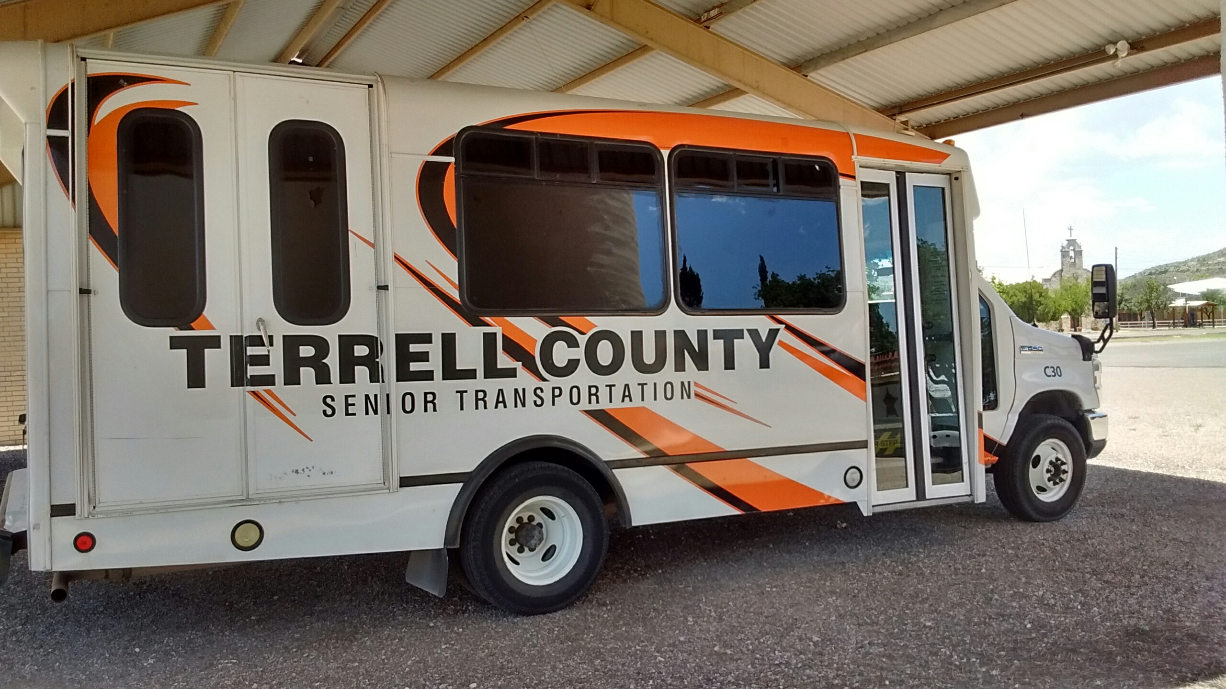

TERRELL COUNTY IS TAKING APPLICATIONS FOR A PART-TIME NON-CDL DRIVER FOR THE SENIOR TRANSPORTION PROGRAM. DRIVER MUST HAVE A GOOD DRIVING RECORD, BE WELL-ORGANIZED, DEPENDABLE. DRIVERS MUST SUCCESSFULLY COMPLETE CPR/FIRST AID TRAINING WITHIN 60 DAYS OF EMPLOYMENT. PRE-EMPLOYMENT SUBSTANCE ABUSE TESTING REQUIRED. APPLICATIONS MAY BE OBTAINED AT THE DISTRICT/COUNTY CLERKS OFFICE DURING REGULAR BUSINESS HOURS. APPLICATIONS MUST BE RECEIVED BY **5:00 PM ON** **FRIDAY JUNE 30, 2023**. Terrell County is an Equal Opportunity Employer.